**ST.XAVIER’S COLLEGE**

MAITIGHAR, KATHMANDU



**Computer Graphics**

Assignment #8

Submitted By:

Binod Paneru

013BSCCSIT014

2nd year/ 4th semester

Submitted to:

|  |  |
| --- | --- |
| Er. Anil Shah  Lecturer  Department of Computer Science |  |

**ALGORITHM:**

1. Get the width and height of the source image
2. Get parameter for reflection axis (1 for x-axis, 2 for y-axis)
3. For each point i in width

For each point j in height

If parameter==1

The translated point (x’, y’) is given by

x' = i

y’ = - j

If parameter==2

The translated point (x’, y’) is given by

x' = - i

y’ = j

Plot the points (x’, y’) with the same color as source in destination

1. Stop

**SOURCE CODE:**

//---------------------------------------------------------------------------

#include <vcl\vcl.h>

#pragma hdrstop

#include "Unit1.h"

//---------------------------------------------------------------------------

#pragma resource "*.dfm"

TForm1 *Form1;

//---------------------------------------------------------------------------

__fastcall TForm1::TForm1(TComponent* Owner)

: TForm(Owner)

{

}

//---------------------------------------------------------------------------

void __fastcall TForm1::Reflection_xClick(TObject *Sender)

{

int x=Image1->Width;

int y=Image1->Height;

for(int i=x;i>=0;i--)

{

for(int j=y;j>=0;j--)

{

int a=x-i;

int b=j;

Image2->Canvas->Pixels[a][b]=Image1->Canvas->Pixels[i][j];

}

}

}

//---------------------------------------------------------------------------

void __fastcall TForm1::Reflection_yClick(TObject *Sender)

{

int x=Image1->Width;

int Y =Image1->Height;

for(int i=x;i>=0;i--)

{

for(int j = Y ; j>=0; j--)

{

int a=i;

int b=Y-j;

Image3->Canvas->Pixels[a][b]=Image1->Canvas->Pixels[i][j];

}

}

}

//---------------------------------------------------------------------------

**OUTPUT SCREEN:**

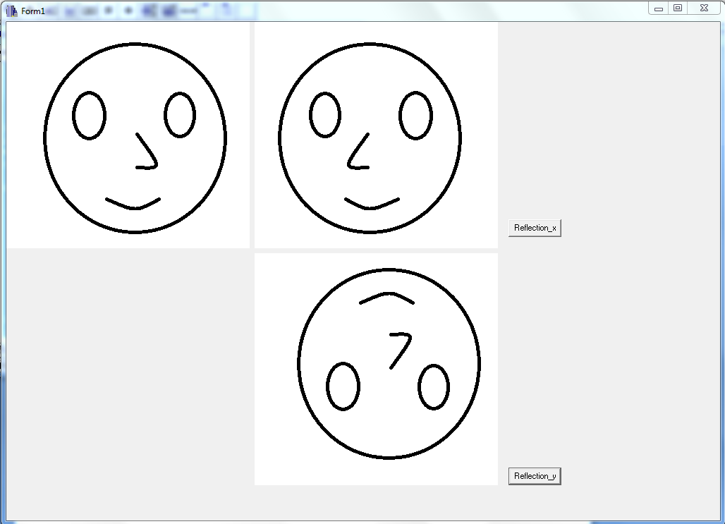

**CONCLUSION:**

Hence, reflection of object was performed using C++ Builder.